GREENDALE MB CHURCH / CHILDREN’S MINISTRIES / CROSSWALK

Be a volunteer in Children’s Ministries

Dear Youth Applicant…

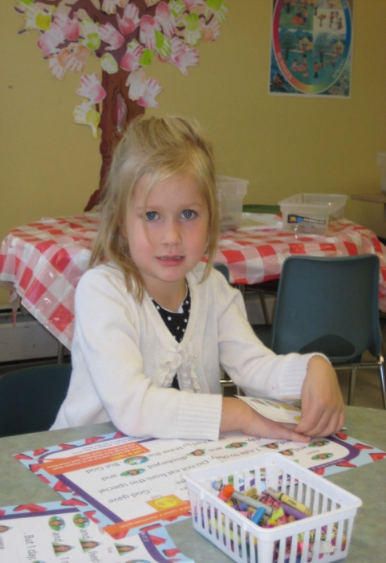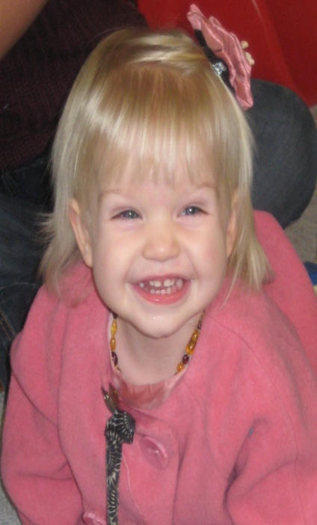
Let me begin by thanking you for your desire to join the Children’s Ministry team here at Greendale MB Church….
We are so excited about what God is doing and the privilege we have of joining Him in His work. Please fill out the enclosed forms and return them to the Children’s Ministry Office. You will receive a call for an interview.
Please find enclosed:
- Application form: Complete and return this form (A parent may help as needed).
- Plan to Protect: Read, sign and date both portions and return bottom portion to the Director of Children’s Ministries

God Bless you!
The Children’s Ministry Team

GREENDALE MB CHURCH / CHILDREN’S MINISTRIES / CROSSWALK

VOLUNTEER APPLICATION for MINORS

Procedures for Minor Age Applicants
Parents: Read this page BEFORE filling out the application

Dear Parents,

We welcome your son/daughter to apply to serve! For the protection of our workers, our children, and the church, everyone ages 12-101 who works with children at GMB Church is asked to complete an application form. We ask that you assure us, to the best of your ability, that your son/daughter is not struggling with anything that would put other children at risk. If you are in doubt or have any questions about this process, do not hesitate to contact me.

Specific Instructions for Minor Age Application

Note: Minors (age 9-15) DO NOT complete a background check or a Ministry Covenant.

Ages 12-17:
- Fill out the Application Form (a parent may help as needed)
- Please list adult references. We will check references.
- Have an age-appropriate “interview” with the Director of Children’s Ministries.

We look forward to receiving your application and talking with you more.

For the joy of the next generation,

Cherith Rast
Director of Children’s Ministries
Greendale MB Church
604 823-6364 ext. 106
gmbkids@shaw.ca

GREENDALE MB CHURCH / CHILDREN’S MINISTRIES / CROSSWALK

Application for Ministry in Crosswalk – MINORS

PERSONAL INFORMATION
Applicant’s Name: ___________________________________ Date: ______________________
Male Female
Date of Birth: _______________________________________ Email: _____________________
Parents’ Names: ________________________________________________________________
Home Phone: ___________________________ Cell Phone: _____________________________
Address: ______________________________________________________________________
^{(Street Number & Name)} ^{(City)} ^{(Postal Code)}
Hobbies, Interests or Skills: _______________________________________________________

SPIRITUAL HISTORY
How long have you attended Greendale MB Church? _________________________________
Are you a member? ____________________________________________________________
When did you accept Christ as your Savior? _________________________________________
Have you been baptized? ________________________________________________________

REFERENCES
Please provide the names of three individuals (adults), excluding relatives, who could provide a reference for you.
- Name of Reference ________________________________________________________
Address _____________________________________ Phone ____________________
- Name of Reference ________________________________________________________
Address _____________________________________ Phone ____________________
- Name of Reference ________________________________________________________
Address _____________________________________ Phone ___________________

GREENDALE MB CHURCH / CHILDREN’S MINISTRIES / CROSSWALK

GENERAL INFORMATION
Help us match current ministry opportunities with your interests and gifts.
What kind of role are you interested in? And what age groups are you interested in serving? You may check more than one. We encourage a 6 year age difference (or more) between volunteers and those they are serving.
If you are familiar with the job titles below, check the ones that interest you. If you are unsure, check “ Other Role” and describe what you would like to do.
Youth-in-Training:
Little Lambs Nursery Caregiver (birth – walking (or 1 year)) Drama/Puppet Ministry
Loving, nurturing caregivers strive to lay a solid spiritual
foundation in the lives of the littlest ones at GMB Church through
intentional prayer, Bible lessons, and biblical truths.

The Wild Kingdom (1 – 2 years old) Crafts preparation
Small Wonders (3 – 4 years old) VBS
Sprouts (5 – 6 years old) Other Role
Kid’s R.O.⁴C.K. (Kid’s Reaching Out ⁴ Christ’s Kingdom!)
Grade 2
Grade 3
Grade 4
What motivates you to become involved in ministry with children? _________________
____________________________________________________________________________________________________________________________________________________________
Are you prepared to attend Plan to Protect meetings as well as any other training meetings that are required? ______________________________________________________

