GREENDALE MB CHURCH / CHILDREN’S MINISTRIES / CROSSWALK / YOUTH

Be a volunteer in Children’s Ministries

Dear Adult Applicant…

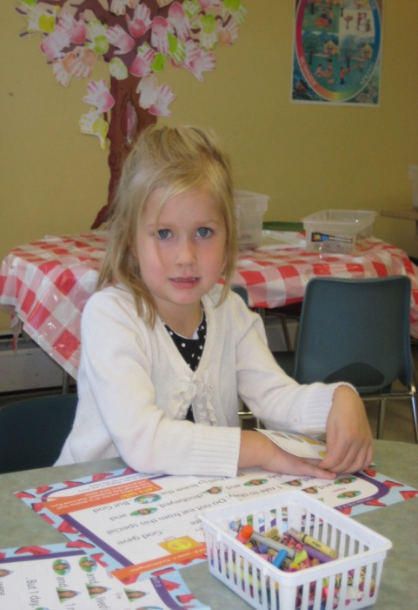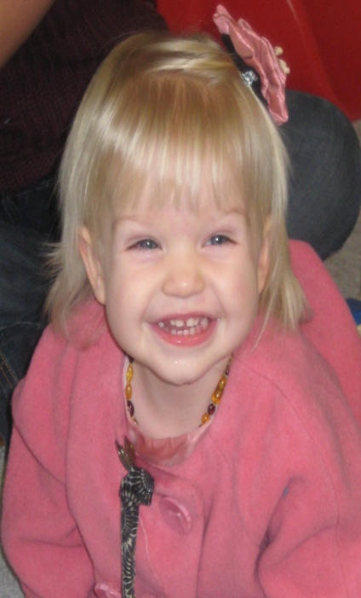
Let me begin by thanking you for your desire to join the Children’s Ministry team here at Greendale MB Church….
We are so excited about what God is doing and the privilege we have of joining Him in His work. Please fill out the enclosed forms and return them to the Children’s Ministry Office. You will receive a call for an interview.
Please find enclosed:
- Application form: Complete and return this form
- MB Confession of Faith: Read and initial beside #10 on the Covenant form.
- Covenant form: Please read, sign and return the covenant form.
- Police record check: An invitation via email will be sent to you. Please answer the questions and respond in a timely manner OR, you may pick-up forms from the Ministry Lead and take them to your local Police Department.
God Bless you!
The Children’s Ministry Team

GREENDALE MB CHURCH / CHILDREN’S MINISTRIES / CROSSWALK / YOUTH

MINISTRY LEADERSHIP VOLUNTEER / APPLICATION FORM
{INFORMATION RECEIVED IS STRICTLY CONFIDENTIAL}
Children’s Ministries
6550 Sumas Prairie Road, Chilliwack, B.C. V2R 4K1
Phone (604) 823-6364 / Fax 604 823-4855 / email gmbkids@shaw.ca

In our desire to reduce the risk of abuse within our church ministries, we believe this information is necessary to protect our children and to protect our volunteers. Thank you in advance for your understanding.

PERSONAL INFORMATION

Full Name: __________________________________________________________________
- Male Female

Phone: (Home) _________________________ (Work) _____________________________
(Cell) ________________________
Address: __________________________________________________________________________
Email Address: _________________________________________________________________
Date of Birth: __________________________________________________________________
Occupation and/or Employer: _____________________________________________________
Hobbies, Interests or Skills: _______________________________________________________

Single Married Engaged Separated Divorced Remarried Widow/widower

SPIRITUAL HISTORY
How long have you attended Greendale MB Church? _________________________________
Are you a member? ____________________________________________________________
When did you accept Christ as your Savior? _________________________________________
Have you been baptized? ________________________________________________________

GREENDALE MB CHURCH / CHILDREN’S MINISTRIES / CROSSWALK / YOUTH

CHRISTIAN EDUCATION HISTORY
Have you completed any Christian Education courses? ________________________________
If yes, give details _______________________________________________________________
Please list any courses or any training you may have taken that would particularly equip you for Christian ministry. ______________________________________________________________
______________________________________________________________________________

CHURCH ATTENDANCE BACKGROUND
Churches I have attended in the last five years are as follows:
- Name of Church __________________________________________________________
Phone number _______________________ Dates attended_______________________
Member Adherent
- Name of Church __________________________________________________________
Phone number _______________________ Dates attended ______________________
Member Adherent

PRESENT AND PREVIOUS MINISTRY EXPERIENCE
- Name of Church __________________________________________________________
Dates and description of Ministry_____________________________________________
Pastor or Ministry Supervisor ________________________________________________
Phone number ___________________________________________________________
- Name of Church __________________________________________________________
Dates and description of Ministry_____________________________________________
Pastor or Ministry Supervisor________________________________________________
Phone number____________________________________________________________

GREENDALE MB CHURCH / CHILDREN’S MINISTRIES / CROSSWALK / YOUTH

LIFESTYLE
In order to provide a safe and secure environment for our children, we believe it is necessary to include the following questions as part of our application process. All information will be kept strictly confidential. Answering “yes” to any of the questions may not necessarily preclude your involvement in ministry. A meeting will be arranged with a Pastor so that you may discuss the circumstances. Thank you in advance for your understanding.

PLEASE ANSWER THE FOLLOWING QUESTIONS
Have you been convicted of a criminal offense involving children? Yes No
Have you been convicted of a sexually related crime? Yes No
Have you been convicted of an abuse related crime? Yes No
Have you been hospitalized or treated for alcohol or substance abuse? Yes No
Do you have any communicable diseases? Yes No
Are you in treatment for any form of mental illness? Yes No

Do you have any physical conditions that would prevent you from performing certain types of activities (lifting children, playing sports)? _________________________________________
If so, please explain. ___________________________________________________________
____________________________________________________________________________

MINISTRY PROFILE
In answering the following, please don’t be too humble as the purpose of this section is for you to declare your strengths so that your gifts will be put to the best use possible. Do not hesitate to mark more than one area below, in which you desire to serve.
Little Lambs Nursery Caregiver Worship Team: singers ___ musicians ____
Nursery Co-Ordinator One on One with additional needs children
The Wild Kingdom Teacher Registration
Small Wonders Teacher Greeters/Hosts
Sprouts Teacher Social or Special Event Planning
Grade 2-4 Teacher Crafts Preparation
Preteen Teacher VBS
Team Coach Sound
Drama/Puppet Ministry Other ________________________________
Media: Photography & Videography _____ Powerpoint _______
Please check off preference of ages to work with:
Infants Toddlers Preschool Kindergarten Gr. 1
Gr. 2 Gr. 3 Gr. 4 Preteens (Gr. 5 & 6) Youth

GREENDALE MB CHURCH / CHILDREN’S MINISTRIES / CROSSWALK / YOUTH

REFERENCES
Please provide the names of three individuals, excluding relatives, who could provide a reference for you.
- Name of Reference ________________________________________________________
Address _____________________________________ Phone ____________________
- Name of Reference ________________________________________________________
Address _____________________________________ Phone ____________________
- Name of Reference ________________________________________________________
Address _____________________________________ Phone ___________________

APPLICANT’S STATEMENT
I hereby acknowledge that the information contained in this application for ministry is correct to the best of my knowledge. I authorize any references or churches listed in this application to give you any information they may have regarding my character and fitness for children’s ministry. I release all such references from liability for any damage that may result from furnishing such evaluation to you. I also grant my permission for Greendale MB Church to perform a personal Criminal Record Check for the purpose of my protection against any false allegations and for the protection of those I serve. I consent to such an investigation with the understanding that the results will be kept in extreme confidentiality. I further agree to adhere to the Plan to Protect Policy as adopted by Greendale MB Church.
____________________________________________ _____________________________
APPLICANT’S NAME – PLEASE PRINT ^{DATE}

____________________________________________
^{APPLICANT’S SIGNATURE}

GREENDALE MB CHURCH / CHILDREN’S MINISTRIES / CROSSWALK / YOUTH

VOLUNTEER COVENANT

A COVENANT FOR CHILDREN AND YOUTH MINISTRY VOLUNTEERS
Maintaining a Christian testimony is essential for Christian leaders. The following is meant to clarify the position of Greendale MB Church in regards to this important matter as it relates to those involved in any area of Children’s Ministry.
- I understand that ministry is a privilege, not a right, and that my desire to serve must, at all times, be affirmed by the church through its screening process.
- I understand that an appointment to a high-risk ministry position requires that I provide a Criminal Records Check as part of the screening process.
- I have confessed Jesus Christ as personal Savior and am now living in fellowship in Him. This includes setting aside time for personal prayer, praise and worship and Bible study.
- I faithfully attend church services.
- I acknowledge that ministering Christ and His Word to children is a high calling. Because of this, I determine to live a biblically exclusive lifestyle that is above reproach in all the areas of my life, both publicly and privately and make myself accountable to godly leadership to this high standard. I choose to be an example to the children and parents of GMB Church and ultimately honoring to God.
- I acknowledge that I am part of a team and as such may be asked to attend meetings and/or conferences that would help me to develop professionally in this ministry.
- I acknowledge that being part of a team means that my faithful attendance and being on time is important to everyone, therefore, I will adhere to the policies and procedures regarding absenteeism and tardiness.
- I acknowledge that from time to time I may be privy to personal family affairs and I accept that I am not to disclose any private information to anyone other than to fellow workers to whom such disclosure would be important for the health and safety to the child(ren) involved.
- I acknowledge that I have read and understand the procedures on Child Abuse and will adhere to the guidelines as outlined for disclosure, in the ‘Plan to Protect’ manual.
- I have read and am in agreement with the MB Confession of Faith. _____ (please initial)
- I have read this page and will abide by the leadership standards stated.
________________________________________ _________________________________
APPLICANT’S NAME – PLEASE PRINT ^{DATE}

________________________________________
^{APPLICANT’S SIGNATURE}

